

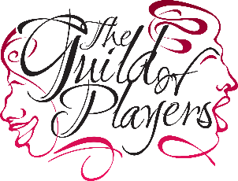
Post partly funded by

Application Form for employment as
Marketing & Communication Officer
Please do send us your C.V. as well as this form.

Surname………………………………………………………………………………………
Other names ………………………………………………………………………………
Address ………………………………………………………………………………………
Postcode …………………………………………………………………………………….
Telephone number …………………………………………………………………….
e-mail address …………………………………………………………………………..
Education and training (school, college, university, training courses)

Please continue on a separate sheet if needed for any boxes.
Present post
Current / Most recent Employment

Reason for leaving

Previous employment

Previous employment.

Please tell us why you are applying for this job.

Why do you think you are the best person for this job?

Please give names and contacts of two referees.

These will be taken up in the event of an interview being offered.

Have you ever been convicted of a criminal offence? Yes No
(Declaration subject to the Rehabilitation of Offenders Act 1974)
If you have a disability, please tell us of any adjustments we may need to make prior to interview.

I can confirm that to the best of my knowledge the above information is correct. I accept that providing deliberately false information could result in my dismissal.

Current PVG membership

Signature .......................................................................................... Date ………………………………..

Application forms should be sent to Theatre Royal,58-70 Shakespeare Street, Dumfries DG1 2JH
or by email to mark@theatreroyaldumfries.co.uk to arrive by
10:00am 15th June 2026

Please put MKO application on the envelope or as the title of your e-mail.

Thank you for your interest in working at the Theatre Royal.


